# ETL Data sources – Test Environment Configuration Set Up

Assumptions:

VM is created with the following tools:

Oracle Client, text editor, browser, Yed, spreadsheet editor, java

Build is deployed

Foodmart is available in the Oracle 12.2, MS SQL 2016, MySQL 5.7, PostgreSQL 9.6, Vertica 9.2, MongoDB 3.2 unsecure

Foodmart sales_fact_1998 and time_by_day is available in Cassandra (Datastax 6.7)

Steelwheels is available in MySQL 5.7

Set Up Steps:

1. Copy down 9.0.0.0 test assets from 172.16.10.71 using scp or tool of your choice from your VM to /home/devuser on Ubuntu and C: on Windows

scp -r [devuser@172.16.10.71:/home/devuser/9.0.0.0](mailto:devuser@172.16.10.71:/home/devuser/9.0.0.0) /home/devuser

**NOTE: You must copy the library to the correct location or execution will not work properly.**

1. Stop the Pentaho server and/or close Spoon on all test VMs dependent on implementation.
2. Copy the following JDBC drivers from /home/devuser/9.0.0.0/resources/JDBC Drivers

to both the data-integration/lib and tomcat/lib folders on all test VMs dependent on implementation.

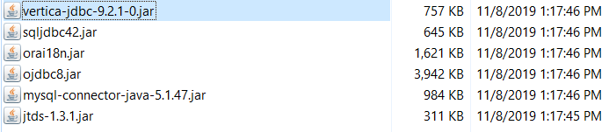

1. Copy the contents of /home/devuser/9.0.0.0/resources/.kettle/kettle-int-ubuntu.properties or .kettle-int-windows.properties to the end of the kettle.properties file on /home/devuser/.kettle for Ubuntu or C:/users/<user>/.kettle on Windows
2. Rename shared.xml to shared-orig.xml in /home/devuser/.kettle – Ubuntu or C:\users\<user>\.kettle
3. Copy shared.xml from 9.0.0.0/resources/.kettle to /home/devuser/.kettle – Ubuntu or C:\users\<user>\.kettle
4. Delete Karaf caches for data-integration/system/karaf/caches and Pentaho-server/Pentaho-solutions/system/karaf/caches
5. Restart Pentaho server

You are Now Ready to Run Any Tests that Use This Configuration.